V578 BUS INTERFACE

Version 0.1

Revision Table
Date | Rev. | Author | Content of revision | Approval
2005-10-23 | 0.1 | Yong Liu | Write bus interface configuration document

Chip configuration
The CONF pin is used to configure the chip and should be connect to the VSS or VDD before chip reset, after reset, it should be stable in the chip and change at any other time should be no effect.
Configuration input | Description
CONF[2:0] | Host bus interface type  “000” : type 0;  “001” : type 1;  “010” : type 2;  “011” : type 3;  “100” : type 4;  “101” : type 5;  “110” : type 6;  “111” : type 7;

Host interface pin mapping
Pin name | Type0 | Type1 | Type2 | Type3 | Type4 | Type5 |  | Type6 |  | Type7
ADDR  [7:0] | DATA  [15:8] | DATA  [15:8] | DATA  [15:8] | DATA  [15:8] | ADDR  [7:0] |  | ADDR  [7:0] | ADDR  [7:0] | ADDR  [7:0]
CPU_A8 | A1 | A1 | A1 | A1 | CPU_A8 |  | CPU_A8 | CPU_A8 | CPU_A8
CPU_RS | Low | Low | Low | Low | CPU_A9 |  | CPU_A9 | CPU_A9 | CPU_A9
DATA | DATA | DATA | DATA | DATA | DATA | DATA |  | DATA |  | DATA
CSN | CS# | CS# | CS# | CS# | CS# | CS# |  | CS# |  | CS#
RDN | RD# | RD# | RDL# | high | RD# | RD# |  | RDL# |  | high
WEN | WR# | high | WRL# | R/W# | WR# | high |  | WRL# |  | R/W#
BEN[1] | UBE# | WRU# | RDU# | UDS# | UBE# | WRU# |  | RDU# |  | UDS#
BEN[0] | LBE# | WRL# | WRU# | LDS# | LBE# | WRL# |  | WRU# |  | LDS#
Meaning description
A1: address/data select pin;
RDL: read data low byte enable;
RDU: read data high byte enable;
WRL: write data low byte enable;
WRU: write data high byte enable;
R/W#: CPU write/read signal(68 type);
UBE: upper byte enable;
LBE: low byte enable;
LDS: low data select pin;
UDS: upper data select pin

Commutator pin mapping

Mode | Bus  type | JP  (13,14,11) | JP12 | JP15 | JP17 | JP18 | JP10 | JP7 | JP  (1,3,5,8,2,4,6,9)
V5 |  | Conf  (2,1,0) | RDN | WEN | BEN[1] | BEN[0] | CPU  _A8 | CPU  _RS | ADDR  [7:0]
0 | Mul 0 | 0,0,0 | nOE  (RD#) | nWE  (WR#) | DQM1  (UBE#) | DQM0  (LBE#) | A8 | A9 | DATA  [15:8]
1 | Mul 1 | 0,0,1 | nOE  (RD#) | ‘1’  (HIGH) | FDQM1  (nWE  |DQM1)  (WRU#) | FDQM0  (nWE  |DQM0)  (WRL#) | A8 | A9 | DATA  [15:8]
2 | Mul 2 | 0,1,0 | FnOE  (nOE  |DQM0)  (RDL#) | FnWE  (nWE  |DQM0)  (WRL#) | nOE  |DQM1  (RDU#) | nWE  |DQM1  (WRU#) | A8 | A9 | DATA  [15:8]
3 | Mul 3 | 0,1,1 | ‘1’  (HIGH) | nWE  (R/W#) | DQM1  (UDS#) | DQM0  (LDS#) | A8 | A9 | DATA  [15:8]
4 | Sep 0 | 1,0,0 | nOE  (RD#) | nWE  (WR#) | DQM1  (UBE#) | DQM0  (LBE#) | A8 | A9 | ADDR  [7:0]
5 | Sep 1 | 1,0,1 | nOE  (RD#) | ‘1’  (HIGH) | FDQM1  (nWE  |DQM1)  (WRU#) | FDQM0  (nWE  |DQM0)  (WRL#) | A8 | A9 | ADDR  [7:0]
6 | Sep 2 | 1,1,0 | FnOE  (nOE  |DQM0)  (RDL#) | FnWE  (nWE  |DQM0)  (WRL#) | nOE  |DQM1  (RDU#) | nWE  |DQM1  (WRU#) | A8 | A9 | ADDR  [7:0]
7 | Sep 3 | 1,1,1 | ‘1’  (HIGH) | nWE  (R/W#) | DQM1  (UDS#) | DQM0  (LDS#) | A8 | A9 | ADDR  [7:0]

Multiplex 80 type0
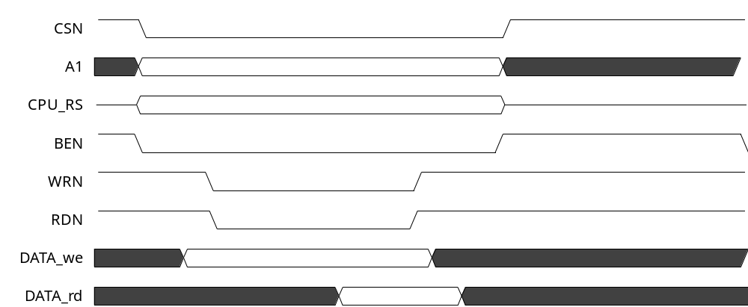
Note: WRN and RDN share using the BEN

Multiplex 80 type1
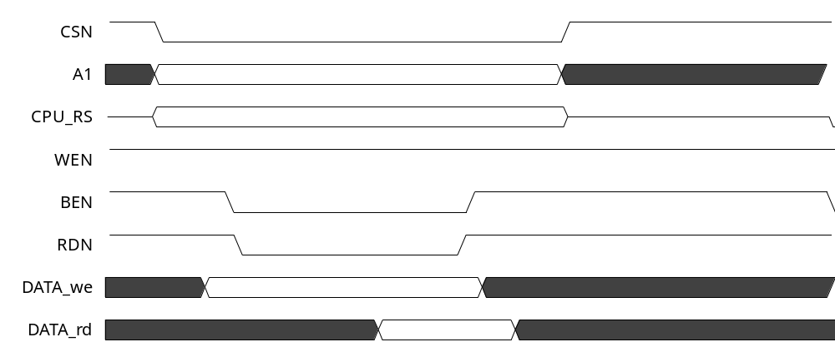

Multiplex 80 type2
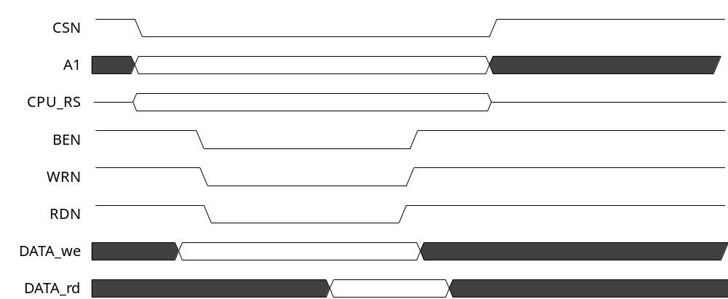

Multiplex 68 type3
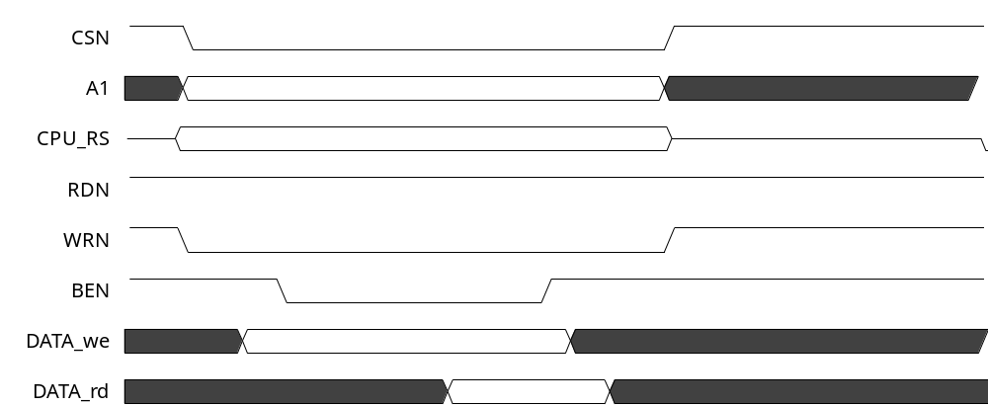

Separate page 80 type4
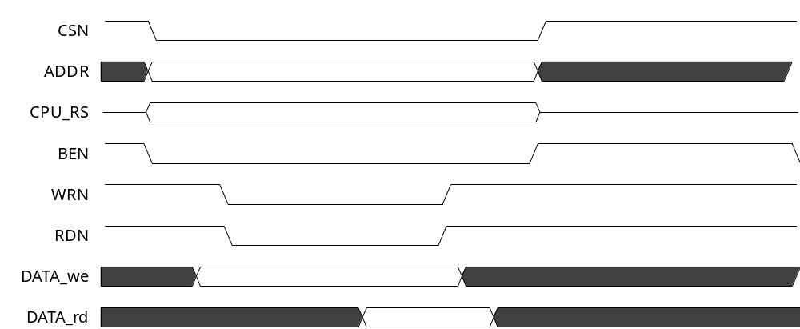

Separate page 80 type5
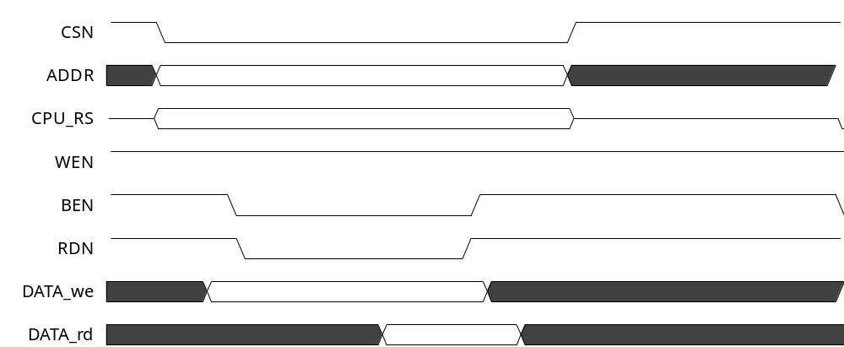

Separate page 80 type6
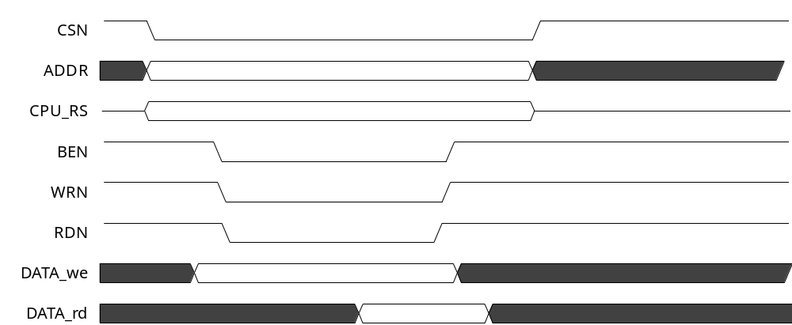

Separate page 68 type7
